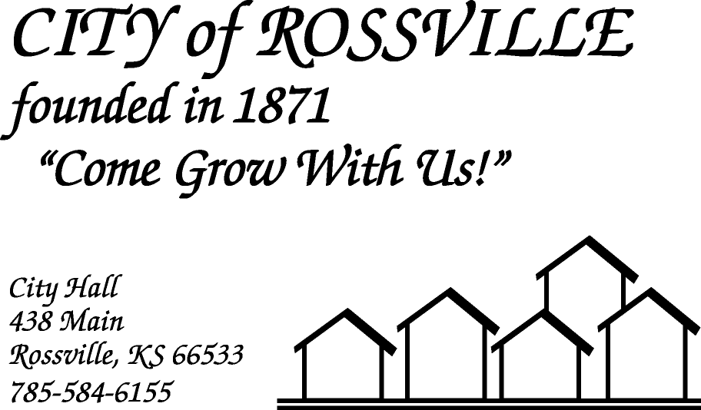

**AGENDA**

**MONDAY**

**AUGUST 3, 2020**

***AGENDA SUBJECT TO CHANGE***

7:00pm MINUTES

BILLS

ADOPT AGENDA

7:05 pm MAURICE ESGUERRA

Business sales in Andrick Park

7:25 pm COUNCIL REPORT

7:35 pm UTILITY DEPT REPORT/BUSINESS

7:45 pm POLICE DEPT REPORT/BUSINESS

7:55 pm OLD BUSINESS

Campbell Field/Stadium lease agreement w/ Beyond Baseball

American Legion Post #31 Dance/beer garden

8:20 pm NEW BUSINESS

8:30 pm ADJOURN

**NOTE: Due to COVID-19 the meeting will be online using ZOOM meeting service**

**Meeting ID: 878 2320 3607**

**Password: 624625**

**Please call City Hall at 785 584-6155 if you need assistance.**